EXECUTIVE SUMMARY

Executive summary for the month of Homebrew’s August performance



Created: 09.09.2019

# INTRODUCTION

For this month of August, we will see who are the top ten active authors (by commits) and generate top 10 contributors (by number lines of code) to projects during this month. Also a comparison between last month and this month’s performance. Any other announcements will also be announced.

# ANNOUNCEMENTS

Nokogiri 1.10.3 has been updated to Nokogiri 10.10.4.

# DATA

Total Number of Commits Made in August: 75

Total Number of Commits Made (not including merges) in August: 45

Top 10 Most Active in August 2019:

32 Mike McQuaid

13 Markus Reiter

12 EricFromCanada

6 dependabot-preview[bot]

5 Jonathan Chang

2 Chongyu Zhu

2 L. E. Segovia

1 Jeremy Mayeres

1 Louis Bergelson

1 Tom Schoonjans

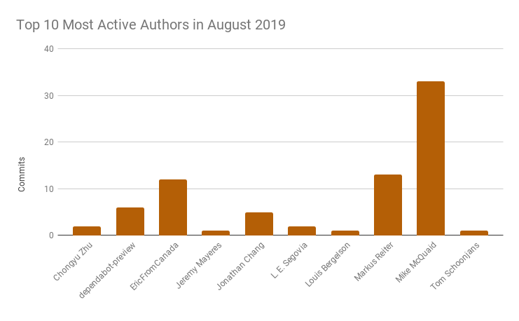

V.S.

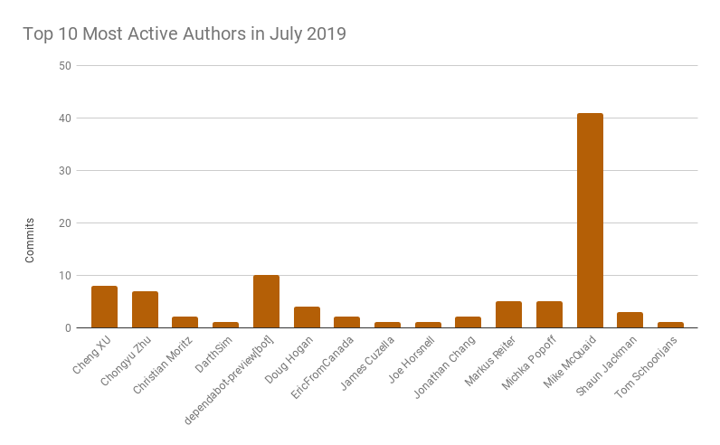

Total Number of Commits Made in July: 92

Total Number of Commits Made (not including merges) in July: 56

Top 10 Most Active in July 2019:

40 Mike McQuaid

10 dependabot-preview[bot]

8 Cheng XU

7 Chongyu Zhu

5 Markus Reiter

5 Michka Popoff

4 Doug Hogan

3 Shaun Jackman

2 Christian Moritz

2 EricFromCanada

2 Jonathan Chang

1 DarthSim

1 James Cuzella

1 Joe Horsnell

1 Tom Schoonjans

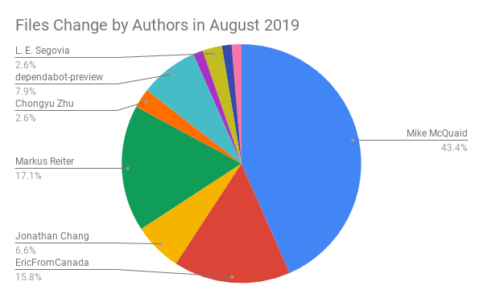

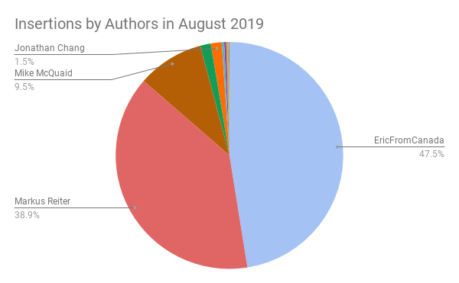

# CONCLUSION

To conclude, last month in July, there were more active authors than this month. However, this does not necessarily mean that our productivity is decreased. As always, Mike McQuaid remains as the most active author in July and August. Mike is also leads in File Changes in August. EricFromCanada is the top in Insertions and Deletions. In this month, Homebrew was also able to update Nokogiri. More updates and projects will be announced next month.